SPARK: Simple Play Adaptations to Reference for Kids

Tote with Clear Pocket Pages
Description: | Image:
Tote with Clear Pocket Pages consists of six, 9” x 6” usable surfaces made of clear vinyl pocket pages. The outside (cover) of the tote is made of waterproof nylon with webbing handle and tab hook/loop closures for easy open/close. | 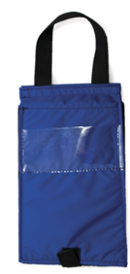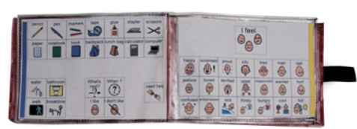  Purchasing Information

Who Might Benefit?
Those who…
• Need symbol support to express or receive information.
• Need a means of transporting their communication supports to have them available at all times.
Why Use?
Provides an opportunity to…
• Communicate with partners in many locations, especially in those not suitable for a more complex communication system.
• Have a wide variety of communication symbols available on six pages of 9” x 6” clear vinyl pocket pages available at all times.
• Carry their communication support independently.
Instructions for Use: | Adaptation Ideas:
Environmental Considerations  - Easily use in almost any environment because of the small size, weight, and easy transportability.  - If this particular style of communication is selected, make sure it is available is all child’s customary environments (e.g. home and school) to provide structure and routine, improve understanding, avoid frustration and offer opportunities to interact with others.  Positioning  - Use in most any position due to the size, portability, and minimal weight. It can be used on a table top, placed on the floor, positioned on a slant board, etc. A child could use it in positions such as sitting, standing, prone (Tummy Time position), supine (laying on their back), kneeling, etc. Provide at optimal viewing level and ensure its within reach of the child.  Basic Play/Use  - Introduce the Tote with Clear Pocket Pages to the child and explain it is going to be used for.  - Be consistent in the use of visuals.  Extended Play/Use  - Model use of the pages within the tote. | Optional Additional Materials/Supplies  - Velcro  - Sheet protectors  - 3-ring binders with clear view covers  - Laminator and lamination sleeves  - Duct tape  Build It Up  - Build up handle for easy gripping or to provide high contrast.  Simplify It  - Start with only a few photos or visual symbols on each page based on the child's ability to understand and select responses, adding more as needed.  - Consider organizing pages by attribute (schedule, food choices, etc.)  Stabilize It  - Velcro to various surfaces in the environment as needed so it does not shift while the child is attempting to access it.  Add Sensory Cues  - Consider using high contrast visuals and/or contrasting background.  - Cut around the shapes of the visuals selected to be displayed and glue to high contrast background (ex: yellow or black paper).  - Tab/color code pages to help child locate what they want to say.  Alternative Uses  - Can be used to display schedules, task sequences, etc.  DIY Alternatives  - Create a wearable communication notebook from a 3-ring binder (3-ring binders come in a variety of sizes) and add a carrying strap.  - Cut and laminate various colored tabbed file folders  - Add strips of Velcro for attaching visuals  - Punch holes in pages and insert into notebooks  - Label tabs.  - Use sheet protectors and print pages of visuals to be placed within.  - Purchase double sided trading card collector sleeves (9 pockets to standard notebook sized sheets) and insert visuals into pockets. Place sheets in standard 3 ring binder.

Additional Considerations:
- Note: Not all children may remember or want to carry the tote with pages throughout the day. Consider use of incentives if necessary.

Resources:
- How to create low tech communication pictures
- Examples of good high contrast color schemes for low vision and why they are important

Note: Research has shown that early use of a communication device does not impact a child’s ability to develop oral speech later and will actually often help to enhance development of oral speech. See: Beyond Spoken Words :Augmentative and Alternative Communication (AAC).

